European Court of Auditors issues clean report for Clean Sky and Joint Undertakings

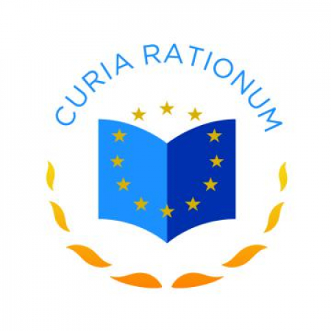

14 November 2019

The European Court of Auditors (ECA) has given a clean bill of health for all the EU’s Joint Undertakings, including Clean Sky. The auditors have signed off the accounts of all eight JUs as reliable, as well as issuing clean opinions on the legality and regularity of their payment and revenue transactions.   
    
In 2018, the EU, as public partner, contributed €2.2 billion to the JUs’ 2018 budget, about 1.5% of the total EU budget. The private partners provide in-kind contributions to operational activities and cash contributions towards administrative costs. JUs mainly award funding to private partners through open calls for proposals.   
    
“Joint Undertakings can improve the link between research and societal growth, and bring innovation closer to the market,” said Ildikó Gáll-Pelcz, the Member of the European Court of Auditors responsible for the audit. “Our audit for 2018 confirms that their financial management is healthy, but we make various observations to indicate areas for improvement as regards in-kind contributions, internal control, grant management and staff turnover.”   
    
Read the full press release [here](https://www.eca.europa.eu/en/Pages/NewsItem.aspx?nid=12889).